**Experiment No:** 08

**Experiment name:**  FCFS Scheduling Algorithm

**Advantages:**

i.This algorithm is very simple to implement.

ii.The aging technique is implemented to reduce the starvation.

**Source Code:**

#include<stdio.h>

int main()

{

int n,bt[20],wt[20],tat[20],avwt=0,avtat=0,i,j;

printf("Enter total number of processes(maximum 20):");

scanf("%d",&n);

printf("\nEnter Process Burst Time\n");

for(i=0; i<n; i++)

{

printf("P[%d]:",i+1);

scanf("%d",&bt[i]);

}

wt[0]=0; //waiting time for first process is 0

//calculating waiting time

for(i=1; i<n; i++)

{

wt[i]=0;

for(j=0; j<i; j++)

wt[i]+=bt[j];

}

printf("\nProcess\t\tBurst Time\tWaiting Time\tTurnaround Time");

//calculating turnaround time

for(i=0; i<n; i++)

{

tat[i]=bt[i]+wt[i];

avwt+=wt[i];

avtat+=tat[i];

printf("\nP[%d]\t\t%d\t\t%d\t\t%d",i+1,bt[i],wt[i],tat[i]);

}

avwt/=i;

avtat/=i;

printf("\n\nAverage Waiting Time:%d",avwt);

printf("\nAverage Turnaround Time:%d",avtat);

return 0;

}

**Result:**

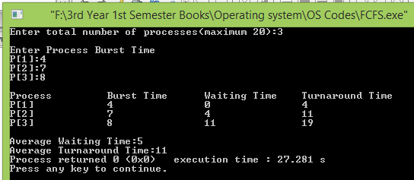

**Conclusion:**

This type of scheduling is one of the very basic algorithm for operating systems in computer which can be implemented through data structure. Our honorable teacher helped us by giving some important lecture which helped us to code these above method.